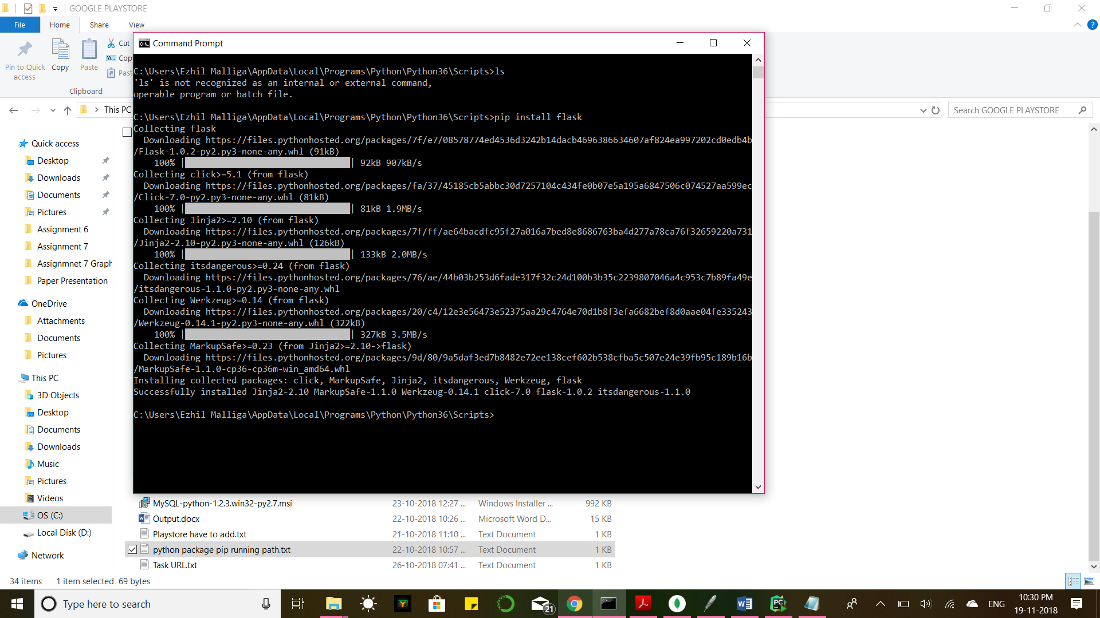

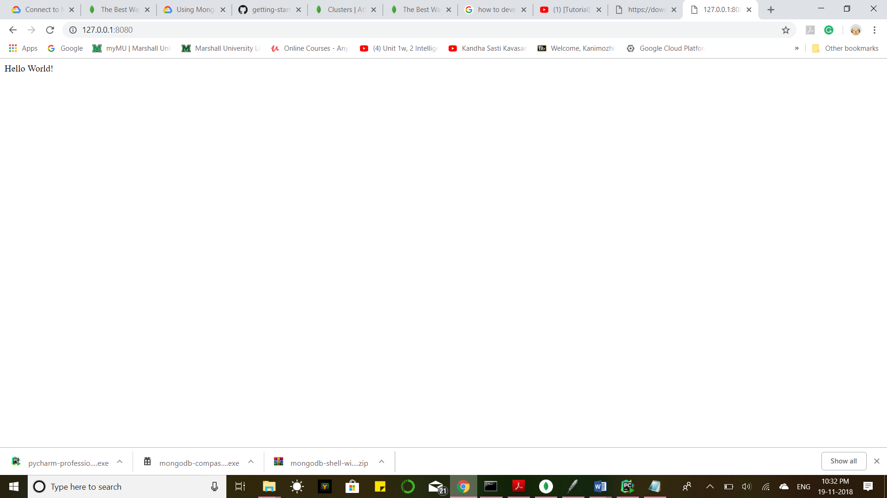

# Copyright 2015 Google Inc.

#

# Licensed under the Apache License, Version 2.0 (the "License");

# you may not use this file except in compliance with the License.

# You may obtain a copy of the License at

#

# http://www.apache.org/licenses/LICENSE-2.0

#

# Unless required by applicable law or agreed to in writing, software

# distributed under the License is distributed on an "AS IS" BASIS,

# WITHOUT WARRANTIES OR CONDITIONS OF ANY KIND, either express or implied.

# See the License for the specific language governing permissions and

# limitations under the License.

# [START app]

from flask import Flask

app = Flask(__name__)

@app.route('/')

def hello():

"""Return a friendly HTTP greeting."""

return 'Hello World!'

if __name__ == '__main__':

app.run(host='127.0.0.1', port=8080)

# [END app]

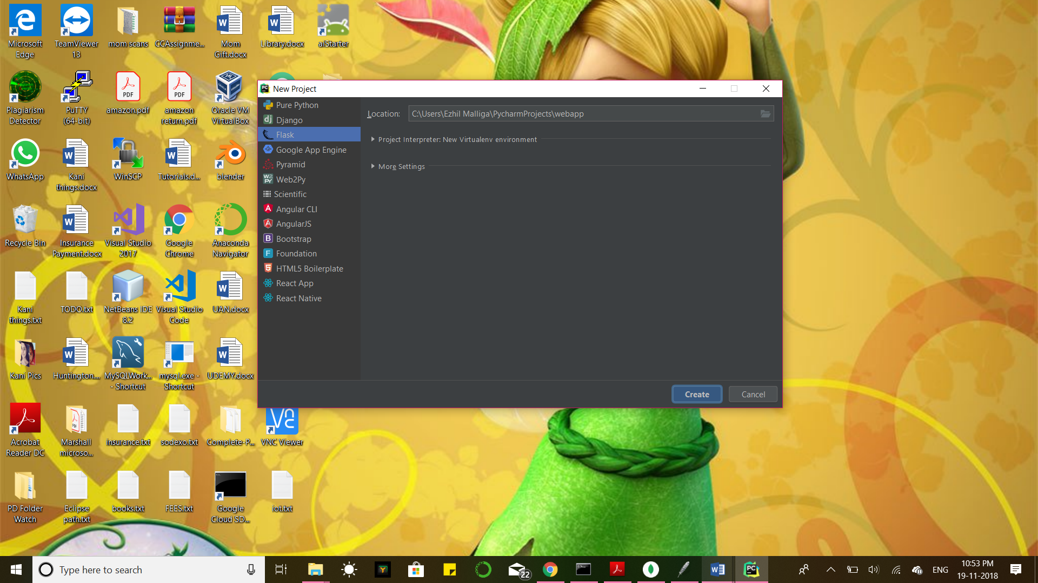

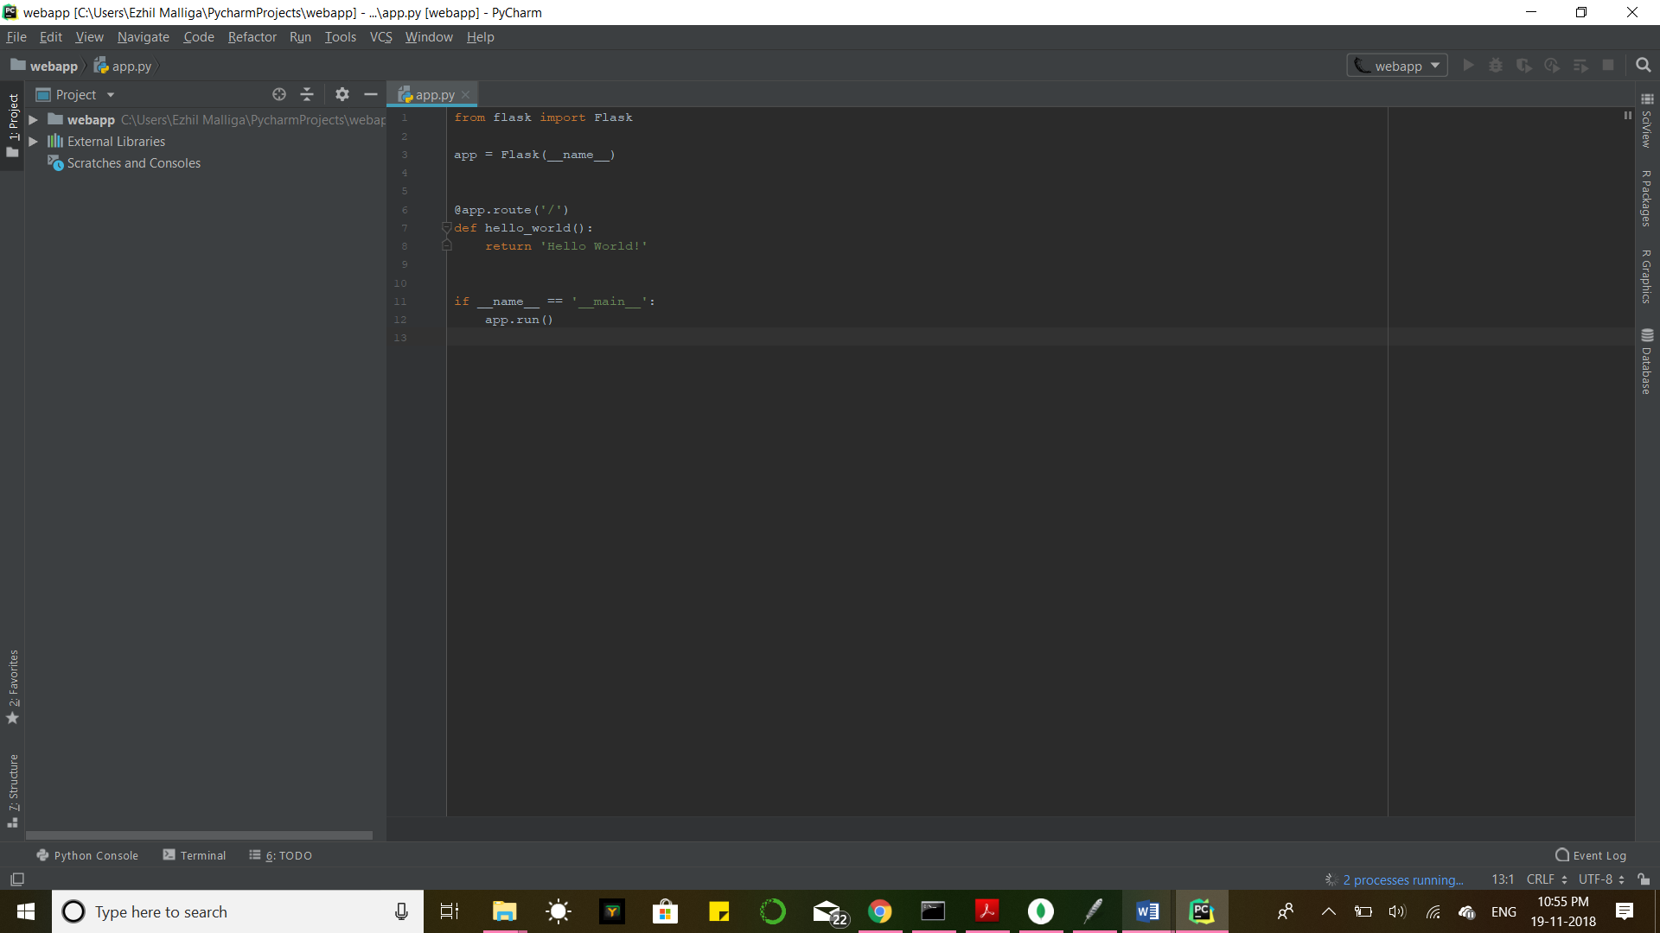

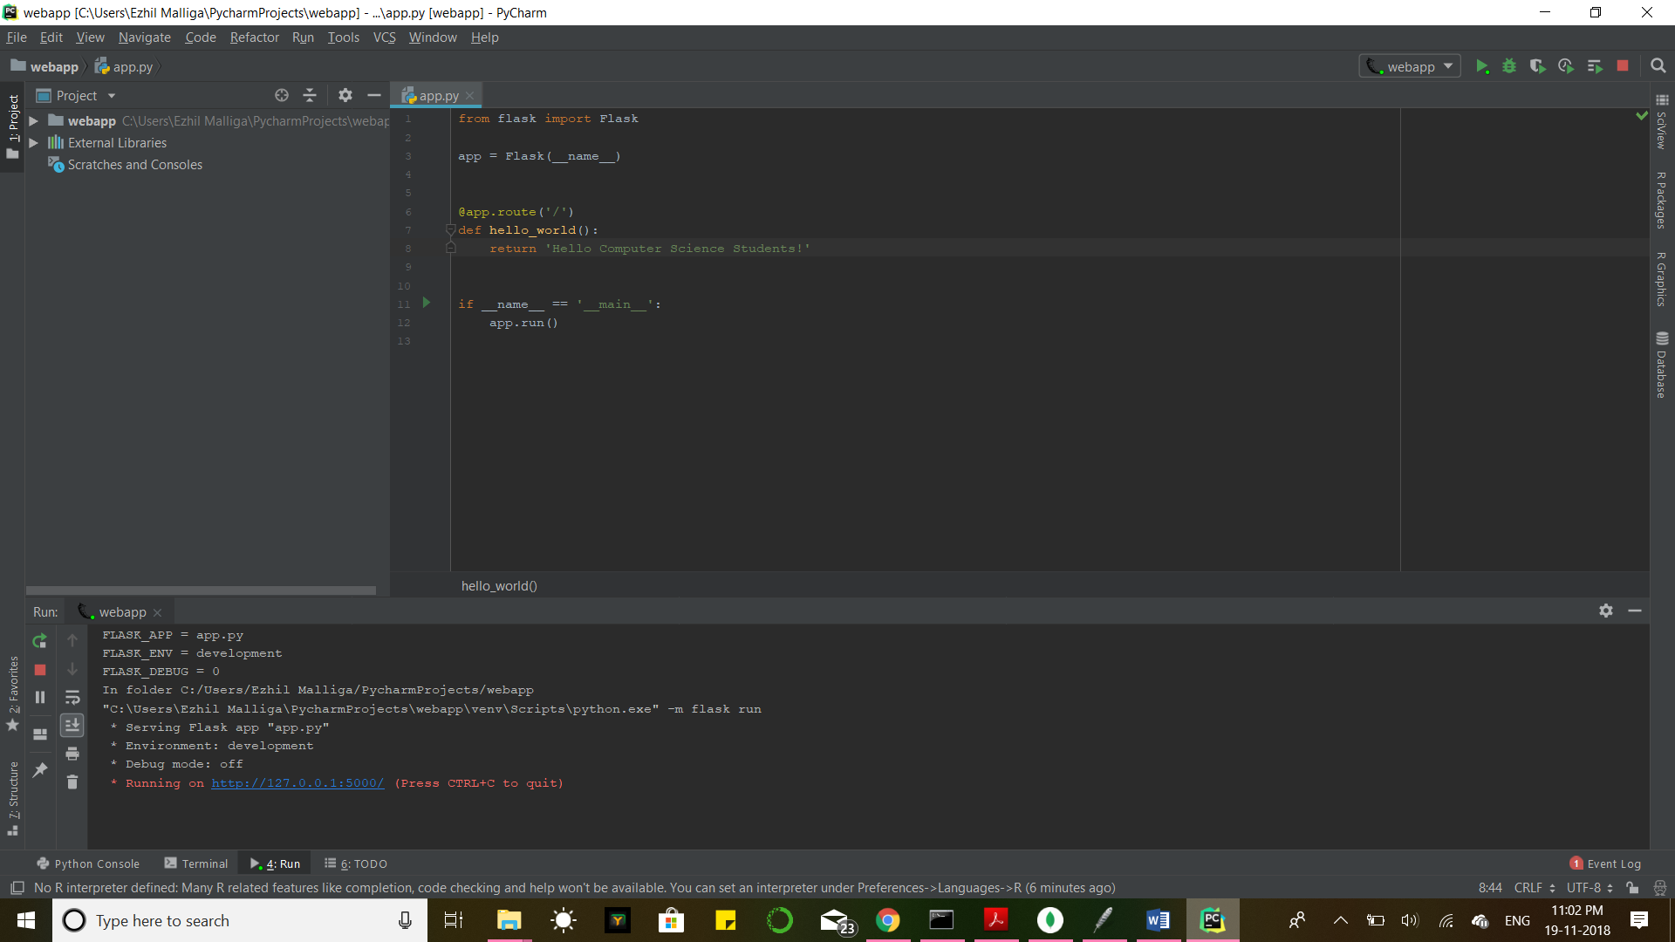

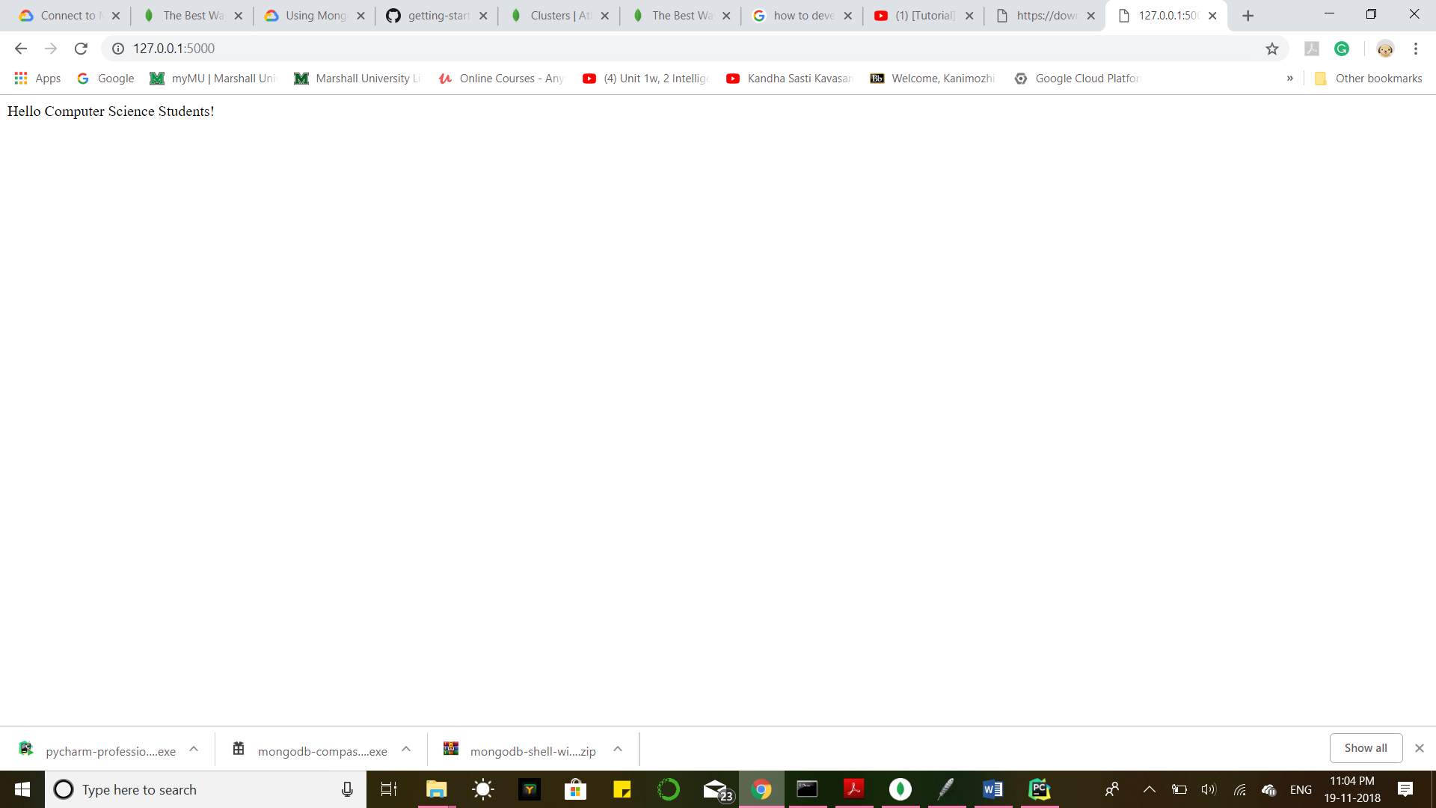

app.run(host='127.0.0.1', port=8080)

MongoDB Stitch:

